Alamein Model Hospital Visit Documentation

1. Visit Background
The visit to Alamein Model Hospital was conducted to understand the current healthcare workflow, patient journey, and existing information systems used within the hospital. The purpose of the visit was to gather requirements for the development of a patient-centered mobile application that enables patients to track their medical condition, treatment plan, appointments, laboratory results, and communication with healthcare providers.

2. Visit Objectives
The main objectives of the visit were:
- Understanding the patient journey inside the hospital.
- Identifying the current workflow of emergency and outpatient services.
- Studying the existing Hospital Management Information System (HMIS).
- Understanding how laboratory, radiology, and pharmacy departments interact with the hospital information system.
- Identifying integration requirements for the proposed patient application.
- Collecting information about patient registration, appointments, and medical records management.

3. Departments Visited
During the visit, the following departments were observed:
- Reception Department
- Emergency Department
- Outpatient Clinics
- Information Technology Department
- Laboratory Department
- Pharmacy Department

4. General Observations
During the visit, it was observed that a significant percentage of the hospital visitors are:
- Local residents of Matrouh Governorate.
- Members of nearby Arab tribes.
- Workers employed in the North Coast region.
This observation highlights the importance of designing a simple, user-friendly, and multilingual patient application that can be easily used by different categories of patients.

5. Patient Triage Process
According to the Deputy Director of the Hospital, every patient entering the hospital undergoes an initial assessment process known as Triage.
The triage process is performed by a Head Nurse, who classifies patients into one of the following categories:

Cold Case
Patients with non-urgent medical conditions.
If the patient arrives during outpatient clinic working hours, they are directed to the appropriate outpatient clinic.
If the patient arrives outside clinic hours, they are received through the reception department.

Emergency Case
Patients requiring urgent medical intervention are immediately transferred to the Emergency Department for further assessment and treatment.

Critical Cases
Patients arriving unconscious, involved in accidents, or suffering from life-threatening conditions bypass the triage stage and are directly transferred to the Emergency Department.

6. Heart Attack Patient Journey
The project focuses primarily on patients suffering from Acute Myocardial Infarction (Heart Attack).
The observed patient journey is as follows:

Scenario 1: Conscious Patient
- Patient arrives at the hospital.
- Patient undergoes triage assessment.
- Patient is examined by the reception physician.
- Required laboratory tests and investigations are requested.
- Diagnosis is established.
- Treatment is initiated.
- Patient remains under observation.

Scenario 2: Emergency Heart Attack Patient
- Patient arrives at the Emergency Department.
- Emergency physician performs assessment.
- Laboratory and diagnostic investigations are requested.
- Diagnosis is confirmed.
- Treatment is initiated.
- Patient remains under observation.

Scenario 3: Critical Patient
- Patient arrives unconscious or with severe trauma.
- Patient is transferred directly to the Emergency Department.
- Immediate emergency intervention is provided.
- Further diagnosis and treatment are performed.

7. Cardiac Catheterization Workflow
The hospital administration emphasized its strong performance in cardiac catheterization procedures.
A key performance indicator used by the hospital is:

Door-to-Balloon Time
This metric measures the time elapsed between:
- Patient arrival at the hospital (Door).
- Balloon inflation during cardiac catheterization (Balloon).
This indicator is internationally recognized as a critical measure of quality in cardiac emergency care.
Following catheterization:
- The patient is transferred to the post-catheterization unit.
- Continuous monitoring is performed.
- The patient may be transferred to the Cardiac Intensive Care Unit if necessary.
- The patient is discharged after stabilization.

8. Existing Information Systems
The hospital currently operates a Hospital Management Information System called:

DMS (Data Management System)
The system is used for:
- Patient registration.
- Appointment management.
- Clinical workflows.
- Laboratory management.
- Administrative operations.
The IT department confirmed that:
- The hospital does not currently own integration APIs.
- APIs can be purchased from the software vendor if integration is required.
The hospital infrastructure operates through a Local Area Network (LAN), connecting all departments to the central system.

9. Reception and Registration Workflow
The reception department is responsible for registering patients and managing appointments.
The registration process includes entering patient information such as:
- Patient name.
- National ID number.
- Mobile number.
- Insurance information.
- Personal details.
The system supports multiple payment methods:

Cash Payment
A standard cash receipt is generated.

Visa/Card Payment
A separate electronic payment receipt is generated.
Different receipt formats were observed during the visit.

10. Laboratory Workflow
The laboratory department is fully integrated with the DMS system.
The workflow is as follows:
- The physician creates a laboratory order electronically.
- The order is automatically sent to the laboratory.
- Laboratory staff perform the requested tests.
- Results are entered into the system.
- Physicians can access the results directly through DMS.
This integration reduces manual communication and improves efficiency.

11. Radiology Workflow
The radiology department uses a separate information system from the main DMS platform.
The system name mentioned during the visit was "Milestone"; however, this information requires confirmation from the IT department.
Different patient categories exist for radiology services:

Economic Patients
Patients who pay the full service cost and receive radiology films.

Health Insurance Patients
Patients receive discounted services but do not receive films unless additional payment is made.

Contracted Company Patients
Patients covered through agreements with private companies receive predefined discounts but must pay separately if they require printed films.

12. Pharmacy Workflow
The pharmacy department is connected to the DMS system.
Three pharmacies were identified within the hospital:
- Emergency/Reception Pharmacy.
- Outpatient Pharmacy.
- Internal Care Pharmacy (location requires confirmation).
The pharmacy system is partially digital and partially manual.

Current Practice
Physicians prescribe medications based on their personal knowledge of drug availability rather than real-time inventory information available within the system.

Inventory Management
When medications are dispensed:
- The dispensing process is recorded in DMS.
- Inventory quantities are updated.
- Remaining stock levels are tracked electronically.

Identified Limitation
Physicians cannot directly view:
- Current medication availability.
- Available quantities.
- Suggested alternatives.
A future integration between physician prescribing and pharmacy inventory could significantly improve efficiency.

13. IT Department Findings
The IT department provided the following information:
- The hospital uses DMS as the primary HMIS platform.
- Laboratory services are already integrated with DMS.
- Radiology uses a separate system.
- APIs are not currently available but can be purchased from the software vendor.
- All departments communicate through the hospital's internal network infrastructure.

14. Recommended APIs
The following APIs are recommended for integration with the proposed patient application:

Authentication APIs
- Login
- Logout
- Patient Verification

Patient APIs
- Get Patient Profile
- Update Patient Information

Appointment APIs
- Book Appointment
- Cancel Appointment
- Reschedule Appointment
- View Appointment History

Medical Records APIs
- Diagnoses
- Treatment Plans
- Clinical Notes

Laboratory APIs
- Laboratory Orders
- Laboratory Results
- Laboratory Report Download

Radiology APIs
- Radiology Orders
- Radiology Reports
- Radiology Images

Pharmacy APIs
- Medication List
- Prescription History
- Medication Availability
- Alternative Medications

Billing APIs
- Payments
- Invoices
- Insurance Coverage

Notification APIs
- Appointment Reminders
- Laboratory Result Notifications
- Treatment Plan Updates

15. Recommendations
Based on the visit findings, the proposed mobile application should initially focus on:
- Patient medical status tracking.
- Treatment plan visualization.
- Appointment management.
- Laboratory results access.
- Heart attack patient journey tracking.
- Notifications and reminders.
- Patient feedback and complaints.
Furthermore, early coordination with the DMS vendor is recommended to assess API availability, integration feasibility, and associated costs.

16. Conclusion
The visit provided valuable insights into the operational workflow of Alamein Model Hospital and its current digital infrastructure. The collected information will serve as a foundation for defining system requirements and designing a patient-centered mobile application that enhances communication, transparency, and healthcare service accessibility.

17. Appendix A – System Screenshots

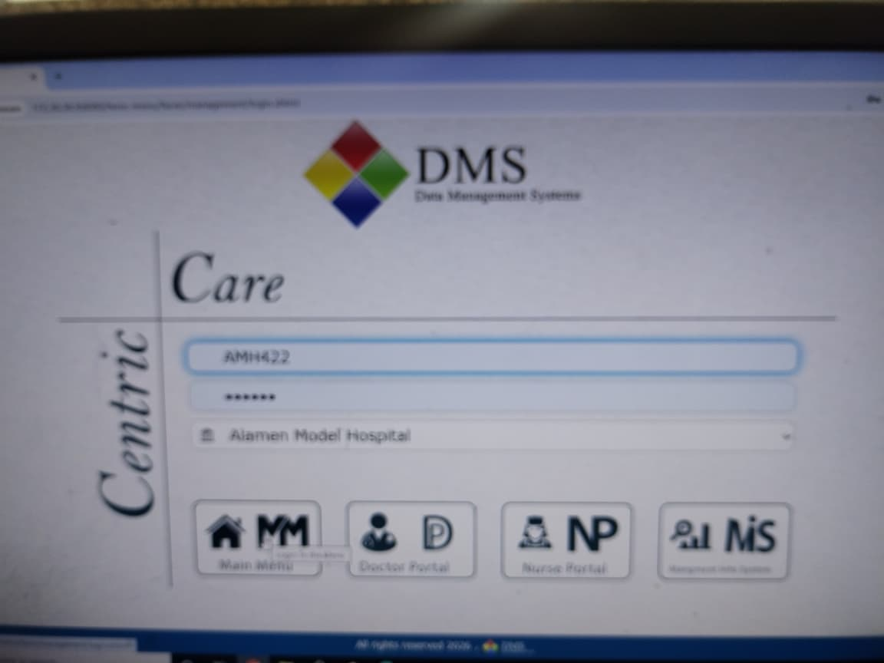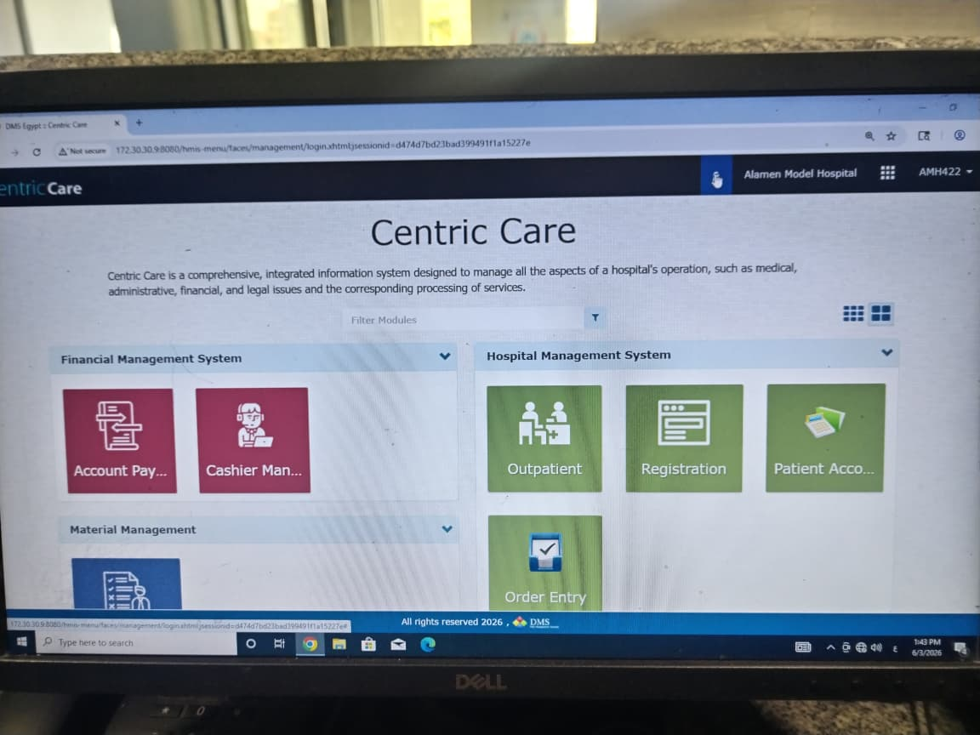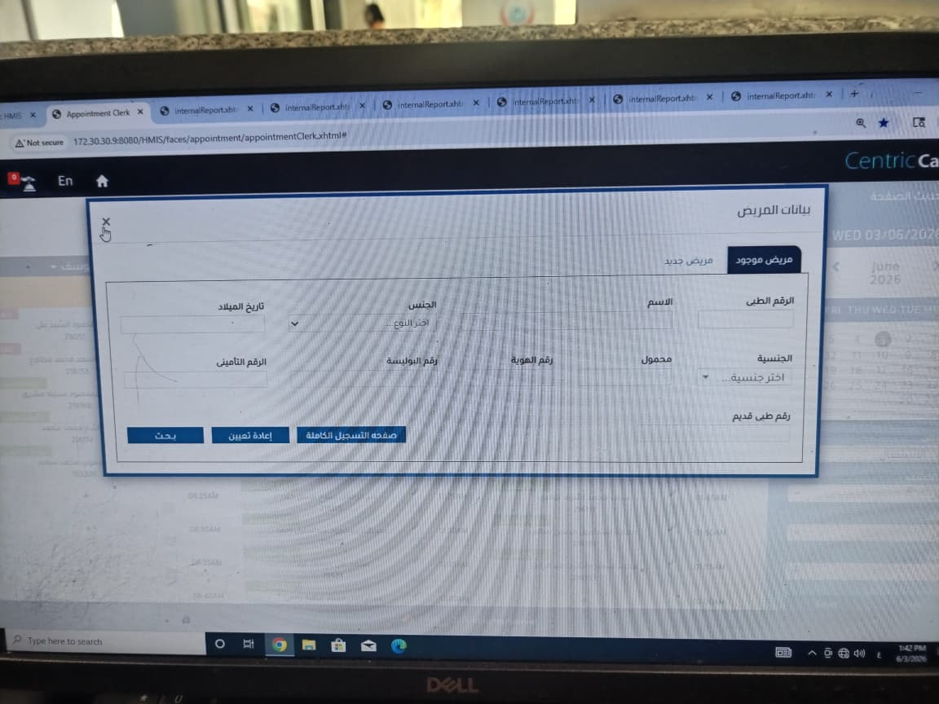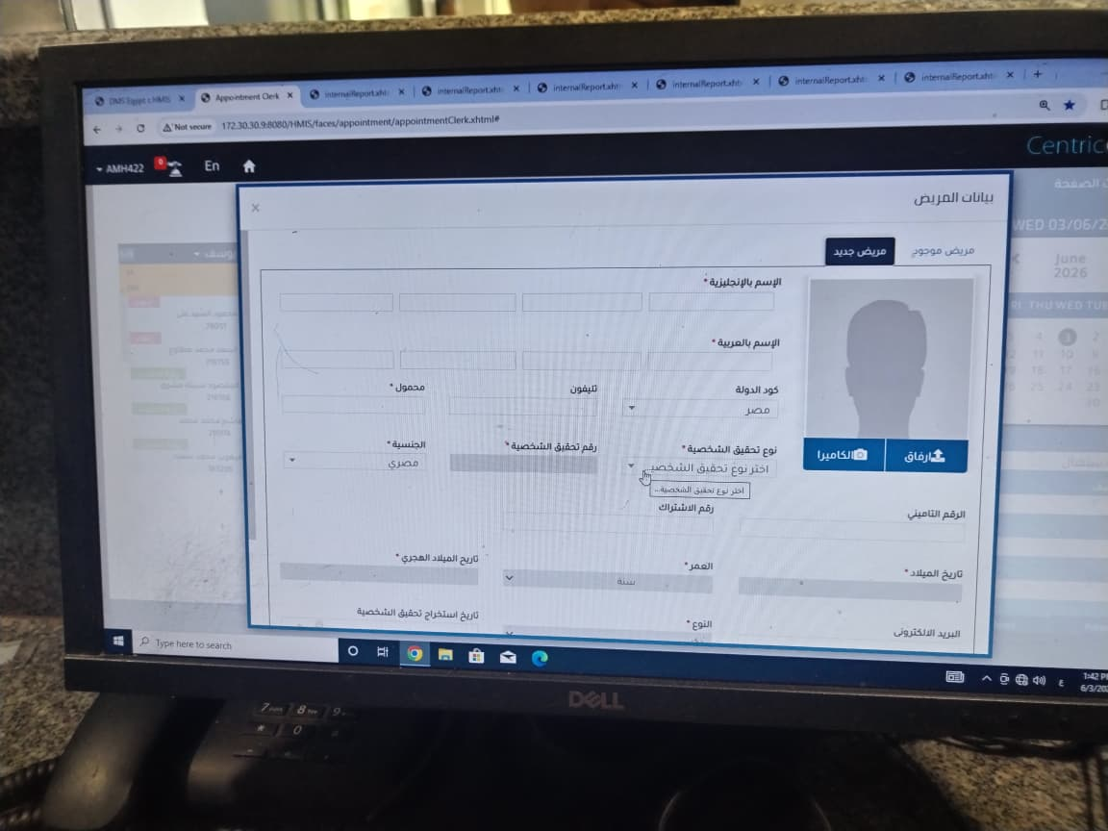

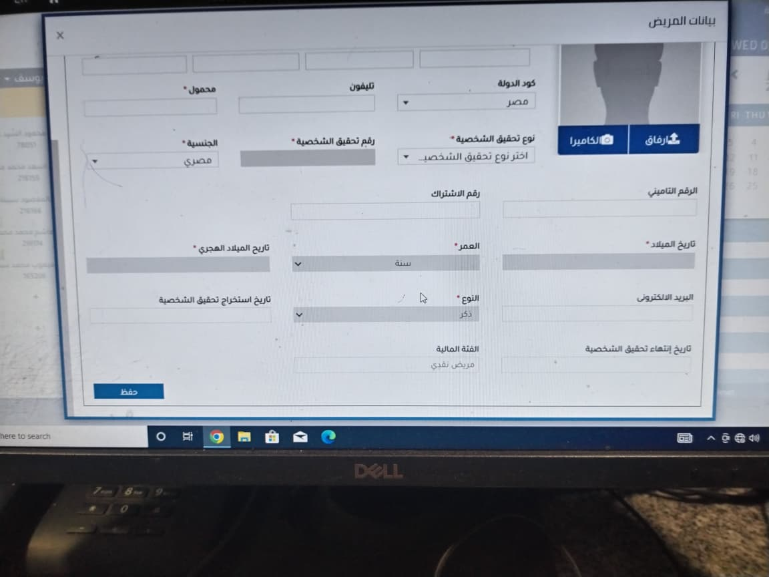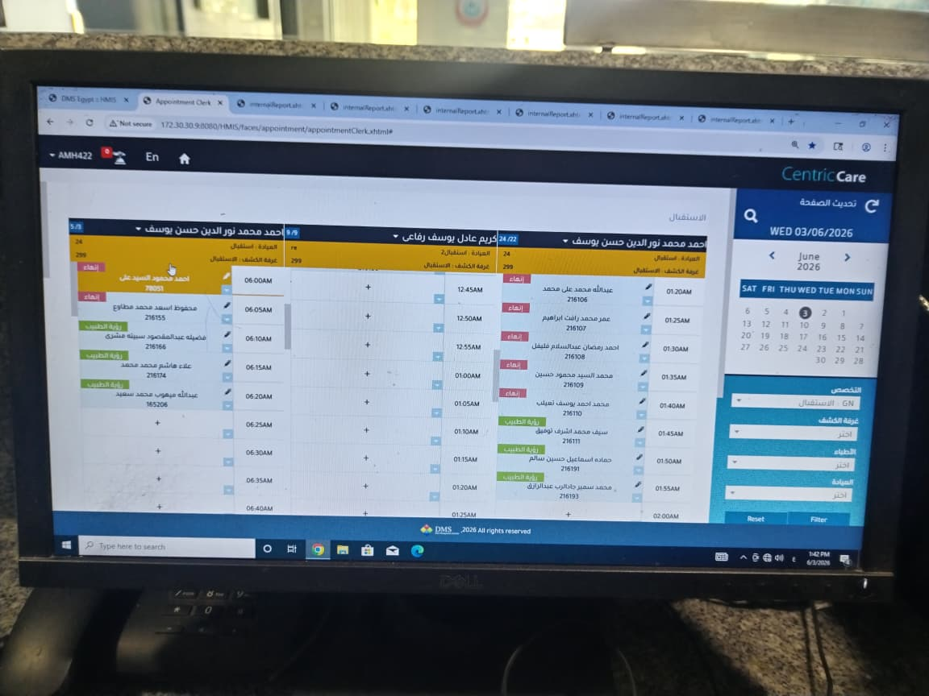

18. Appendix B – Sample Receipts

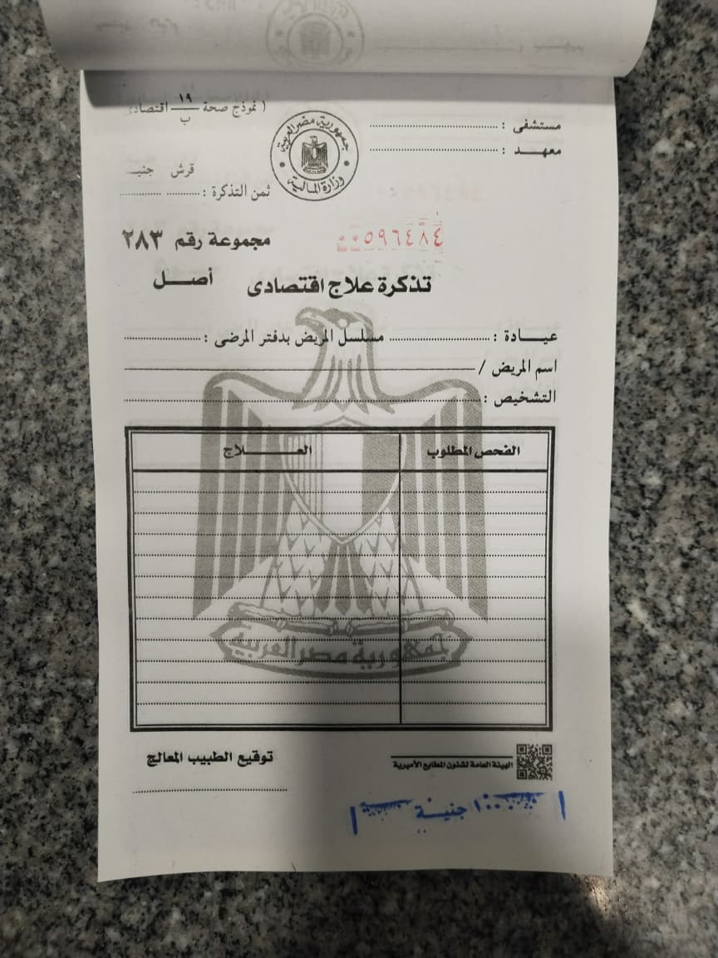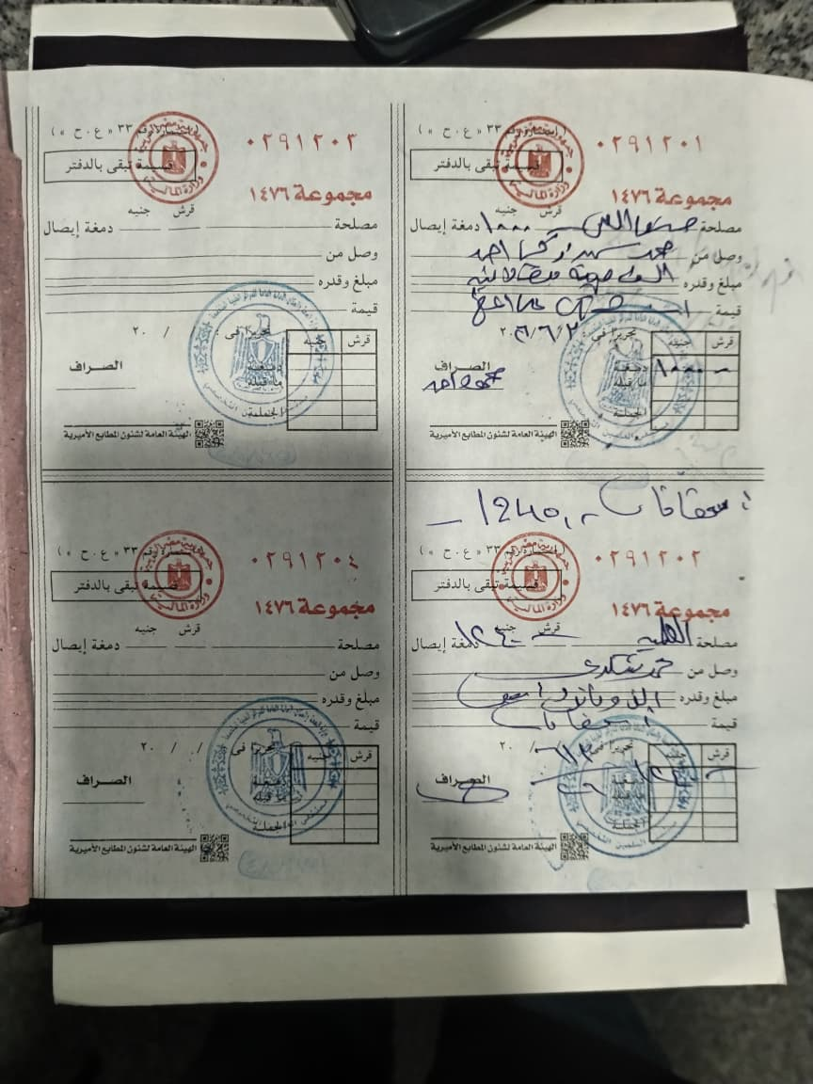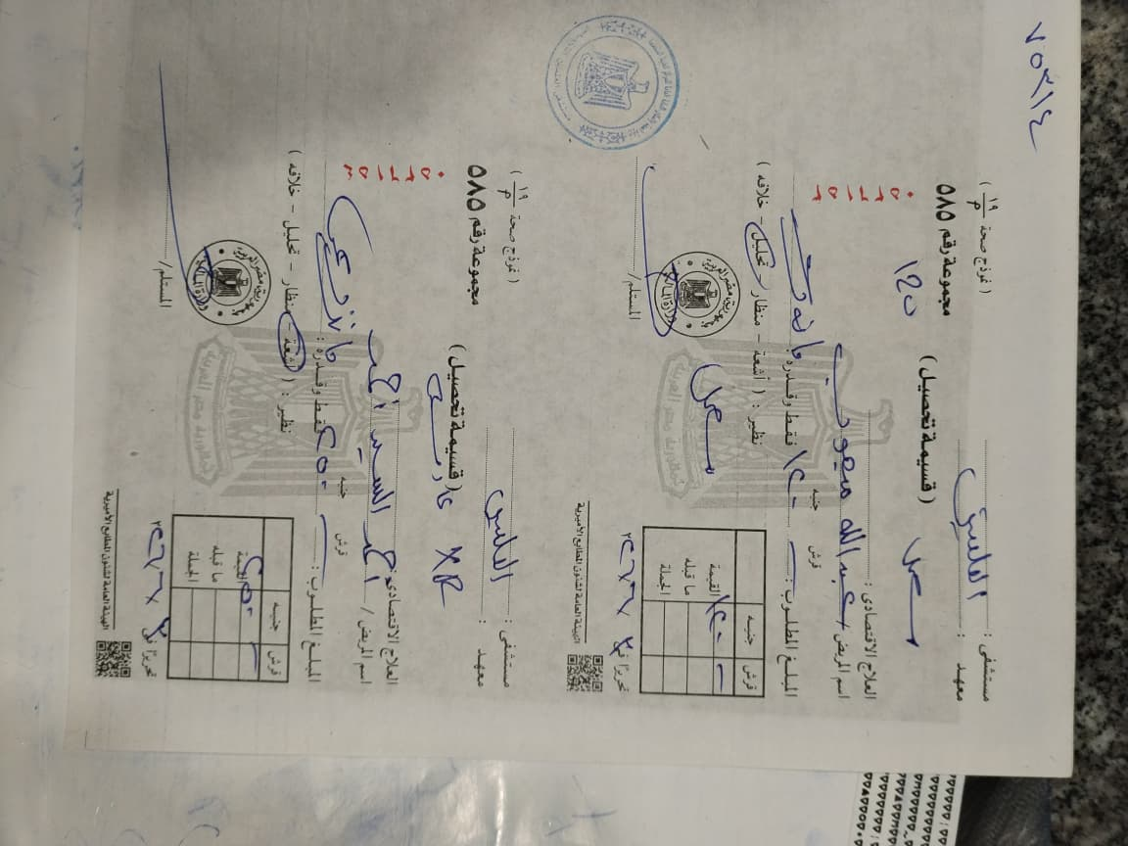

19. Appendix C – Sample Laboratory Report
